Experiment 10: Locally Weighted Regression (LWR)

Aim
To implement the non-parametric Locally Weighted Regression (LWR) algorithm to fit data points and visualize the regression curve.

Description

Regression
Regression is a supervised learning technique used to predict continuous numerical values based on input features.
• It requires labeled data (input-output pairs)
• The model learns relationship between variables
• It predicts continuous output for new data

Locally Weighted Regression (LWR) Algorithm
LWR is a non-parametric regression algorithm that fits the model locally around a query point:
• It does not build a global model
• It assigns higher weights to nearby points
• It uses a parameter τ (tau) to control locality

Applications of LWR
• Curve fitting
• Stock market prediction
• Weather forecasting
• Robotics & control systems
• Non-linear data modeling

Algorithm (LWR)
- Choose bandwidth parameter τ (tau)
- For each test point:
  - Calculate weights for all training points
- Construct weight matrix W
- Compute parameters using weighted regression
- Predict output value
- Repeat for all test points

Dataset Used
Salary Dataset - Simple linear regression

Columns:
- YearsExperience (X)
- Salary (y)

Source Code
# Step 1: Import Libraries
import pandas as pd
import numpy as np
import matplotlib.pyplot as plt
- pandas → to read CSV file
- numpy → for mathematical and matrix operations
- matplotlib → to draw graphs
# Step 2: Load Dataset (CSV from Kaggle)
# Make sure file Salary_Data.csv is in same folder
data = pd.read_csv("Salary_dataset.csv")
print(data.head())
- The dataset is loaded from a CSV file
- head() displays the first 5 rows
# Step 3: Select Features
X = data['YearsExperience'].values
y = data['Salary'].values
- X (input) → Years of Experience
- y (output) → Salary
- .values converts columns into NumPy arrays
# Add bias (1 column)
X_mat = np.c_[np.ones(len(X)), X]
Why needed bias:
$$y = {theta}_{0} + {theta}_{1}x$$we add a column of 1s to represent θ₀ (intercept) in matrix form
Result:
X_mat =
[1 x1
1 x2
1 x3]
# Step 4: Define LWR Function
def locally_weighted_regression(x_query, X, y, tau):
m = len(X)
W = np.eye(m)
This function predicts the output for one query point
- m = number of data points
- W = identity matrix (will store weights)
# Calculate weights
for i in range(m):
diff = x_query - X[i][1]
W[i, i] = np.exp(-(diff ** 2) / (2 * tau ** 2))
- Each training point gets a weight
- Closer points → higher weight
- Far points → lower weight

# Calculate theta
theta = np.linalg.pinv(X.T @ W @ X) @ (X.T @ W @ y)
This is the weighted normal equation
- Weights influence the model
- A new θ is calculated for every query point
# Prediction
return np.array([1, x_query]) @ theta
Final prediction:
- [1, x_query] → input vector
- Multiply with θ → predicted salary
Step 6: Make Predictions
tau = 0.5 # bandwidth (change to see effect)

X_test = np.linspace(min(X), max(X), 100)
y_pred = []

for x in X_test:
y_pred.append(locally_weighted_regression(x, X_mat, y, tau))
- LWR builds a separate model for each test point
- That’s why it is slower than simple linear regression
# Step 7: Plot Graph
plt.scatter(X, y, color='red', label='Actual Data')
plt.plot(X_test, y_pred, color='blue', label='LWR Curve')
plt.title("Locally Weighted Regression (Salary Dataset)")
plt.xlabel("Years of Experience")
plt.ylabel("Salary")
plt.legend()
plt.show()

Output

Unnamed: 0 YearsExperience Salary
0 0 1.2 39344.0
1 1 1.4 46206.0
2 2 1.6 37732.0
3 3 2.1 43526.0
4 4 2.3 39892.0

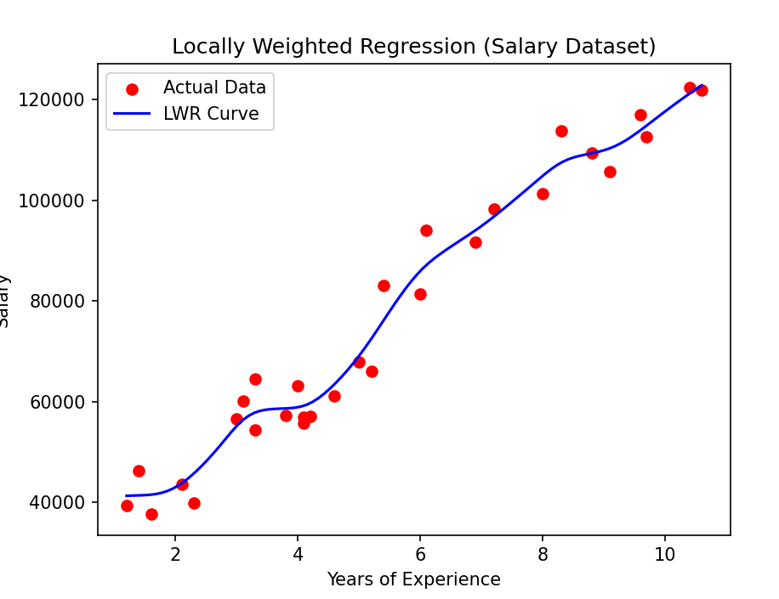
VIVA QUESTIONS
1. What is Locally Weighted Regression (LWR)?
ans: LWR is a non-parametric algorithm that fits a model locally around a query point.
2. Why is LWR called non-parametric?
ans: Because it does not assume a fixed model structure and does not learn global parameters.
3. What is the role of τ (tau) in LWR?
ans: Tau controls the bandwidth (locality).
- Small τ → more local (overfitting possible)
- Large τ → more smooth (underfitting possible)
4. What happens if τ is very small?
ans: Model becomes very sensitive to noise (overfitting).
5. What happens if τ is very large?
ans: Model behaves like linear regression (underfitting).
6. Why does LWR not build a global model?
ans: Because it computes a new model for each query point.
7. What is the weight matrix W?
ans: A diagonal matrix that stores weights of each training point.
8. Why do we add a bias column (1s) in X_mat?
ans: To represent θ₀ (intercept) in matrix form.
9. Why is np.linalg.pinv() used instead of inverse?
ans: It computes pseudo-inverse and avoids errors when matrix is not invertible.
10. Why is LWR slower than linear regression?
ans: Because it builds a new model for every test point.

Test Link ->Experiment 10: Locally Weighted Regression (LWR)

https://docs.google.com/forms/d/e/1FAIpQLScTaB_ois06_gDmn7vo1qvr-NhZbVE23JvB6_ZPP52h_gCs-w/viewform?usp=dialog

